**PROJECT: Displaying User Feedback .**

**Developer Name:** Nellore Sri Lavanya

This document contains contents for:

* Project Description
* Flow of the Application
* Core concepts used in project
* Conclusions.

**1.Project Description:**

* Create a Spring Boot project that will capture user feedback using a REST endpoint.
* The REST resource will take in parameters using HTTP POST.
* The feedback data will be then added to a database table.

**2.Application Flow:**

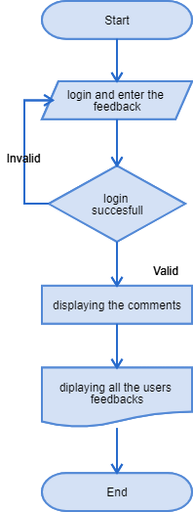

**3.Core concepts used in project:**

● Eclipse as the IDE  
● Apache Tomcat as the web server  
● Spring Boot with Hibernate

**Conclusion:**

* This project is designed for Searching for a Specific User and Updating the User Information.